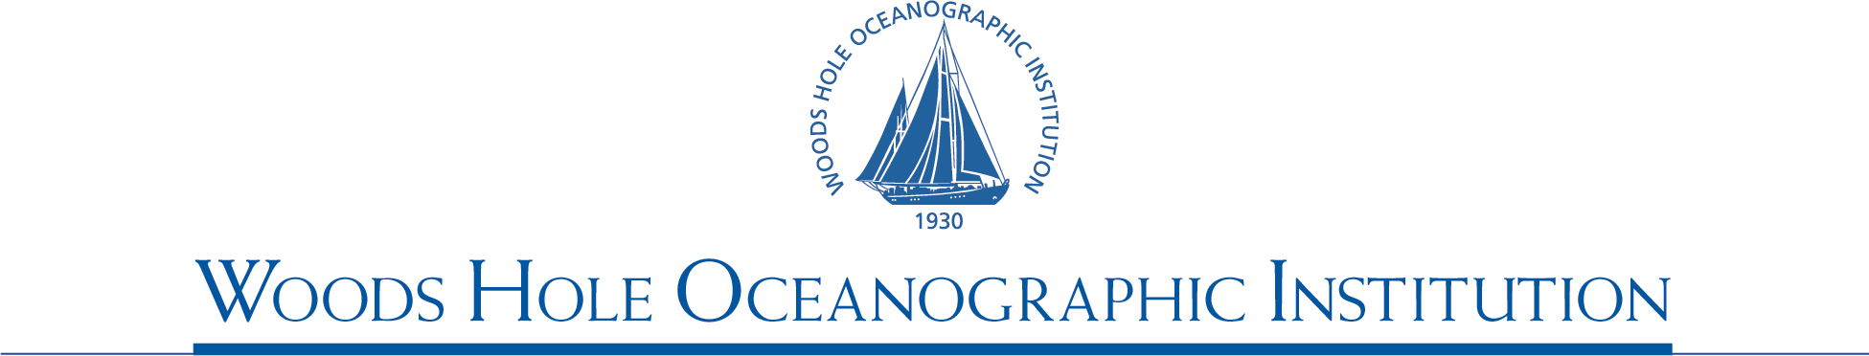
Jeffrey J. McGuire, Associate Scientist
December, 29th 2006
Professor Teruyuki Kato
International Office of Earthquake and Volcano Research Promotion
Earthquake Research Institute
University of Tokyo,
1-1, Yayoi 1., Bunkyo-ku
Tokyo 113-0032, Japan

Dear Professor Kato,
I would like to submit this report on my work while I was a Visiting Professor at ERI this fall. First, I would like to thank you and Professor Iidaka for inviting me and arranging my stay at ERI. It was a great experience for me that will have a long-term impact on the direction of my research program. While I had existing collaborations with ERI/Univ. of Tokyo scientists when I arrived at ERI in September, I now feel confident that these collaborations will be long-term ones. Additionally, the time at ERI allowed me to interact with the marine seismology group at JAMSTEC, and hopefully this will lead to a joint JAMSTEC-WHOI OBS experiment in the not to distant future. In hindsight, I think the most important aspect of my stay will be the various long-term projects that were initiated in the last few months.

In terms of the actual research that I accomplished while I was at ERI, the project that I made the most progress on was the analysis of the moderate (magnitude 3-4) aftershocks of the 2000 Tottori earthquake that were recorded by a dense temporary deployment that many ERI scientists participated in. I am particularly indebted to Professors Iidaka and Hirata for arranging access to this dataset for me. Owing to the experiment design, this dataset appears to be the best in the world for constraining the rupture velocity of moderate earthquakes. I expect that in the next month or so I will begin writing a paper (in collaboration with Professors Iidaka, Hirata, and Ide) on the comparison of rupture velocity between small and large earthquakes. My initial results indicate that the rupture velocity of M3 events is indistinguishable from that of the M6.5 mainshock. This is an unexpected result given conventional wisdom about earthquake scaling between small and large earthquakes, and hence I think it will make a very interesting paper.

Lastly, I would like to thank Drs. Iidaka, Ide, Miyazaki, Miyake, Aoki, Kato, and Sho Nakamula for going out of their way to make sure that I had the opportunity to be involved in many interesting and productive discussions over the course of the fall. I certainly learned a lot about a variety of topics from them. I am also indebted to Watanabe-san, I still can’t believe how easy she made it for a non-Japanese speaking person to become an employee of ERI! Years from now, I am sure that I will still be willing to sign any piece of paper she gives me even if I still can’t read it!

I hope I will have the opportunity to return to ERI for a short visit sometime in the near future to see all of you again.

Sincerely,

Dr. Jeffrey J. McGuire
Associate Scientist
Department of Geology and Geophysics,
Woods Hole Oceanographic Institution
MS#24 • Woods Hole, MA 02543 • 508.289.3290 • Fax 508.457.2150 • jmcguire@whoi.edu

