Effect of stress transfer on the seismic hazard for the Tokai fault

Report of a study carried out during my stage at the ERI, Tokyo from 31 October to 14 December 2008

Rodolfo Console, Istituto Nazionale di Geofisica e Vulcanologia, Rome, Italy

Abstract
This work aims at the assessment of the occurrence probability of future earthquakes on the subduction zone along the eastern coast of Japan, conditional to the time elapsed since the last characteristic earthquake on each fault, and to the history of the following events on the neighbouring active sources. The application is done on the earthquake source known as the Tokai fault. I start from the estimate of the probability of occurrence in the next 10 years for a characteristic earthquake on a specific source, based on a time-predictable renewal model. The occurrence rate of the characteristic earthquake is calculated taking into account the permanent perturbation due to the Coulomb stress change caused by slip on the neighbouring faults after the occurrence of the latest event. The results show that the estimated effect of earthquake interaction in this region is small if compared with the uncertainties affecting the statistical model used for the basic time-dependent hazard assessment.

A time-predictable model for earthquake occurrence probability
The procedure here adopted for seismic hazard assessment assumes that all the large earthquakes occur on known faults for which the mechanism and the size of the characteristic event are given. Modeling the process requires the adoption of a Probability Density Function f(t) for the inter-event time between consecutive events on each fault, and some other basic parameters. Time independent Poisson model and renewal model based on the knowledge of the last event are the approaches most widely used in literature. The time independent Poisson model uses an exponential function to model the occurrence of earthquakes, and only one parameter, i.e. the mean recurrence time is required. The renewal model is the simplest representation of a time-dependent behaviour of seismogenetic processes, and several distribution functions such as BPT (Brownian Passage Time), double exponential, gamma, lognormal and Weibull have been applied.
In lack of observational evidences, in this study I adopt the BPT distribution (Matthews et al., 2002) to represent the inter-event time probability distribution for earthquakes on individual sources. Unlike all the other renewal models, which are based only on an arbitrary choice of the probability density distribution, the BPT is associated to considerations on the fault physical properties (Zöller and Hainzl, 2007). For this model, in addition to the expected mean recurrence time, T_{r}, the coefficient of variation (also known as aperiodicity) α of the inter-event times is required. When α >1, the time series exhibits clustering properties. Values below the unit indicate the possible presence of periodicity, with increasing periodicity for decreasing α.
This distribution function is expressed as:
$f(t;T_{r},α)={\left(\frac{T_{r}}{2{\text{πα}}^{2}t^{3}}\right)}^{1/2}\text{exp}\left\{−\frac{(t−T_{r})^{2}}{2T_{r}α^{2}t}\right\}$ (1)
In this study I manipulate the pdf by discretized numerical integration.
Given the probability density function and the time of the latest event, we may obtain the hazard function h(t) under the condition that no other event has occurred during the elapsed time t (i.e. since the occurrence of the last characteristic event) by the following equation:
$h(t)=\frac{f(t)}{S(t)}=\frac{f(t)}{1−F(t)}$ (2)
Where S(t) is the survival function and F(t) is the cumulative density function.
The hazard function allows the computation of the probability that an event occurs between time t and t+Δt:
(3)
This renewal process assumes that the occurrence of a characteristic event is independent of any external perturbation.

Relations among fault parameters adopted in this study
The scalar seismic moment of an earthquake is defined as
$M_{0}=μ\overline{Δu}S$ , (4)
where μ is the shear modulus of the elastic medium, is the average slip on the fault, and S is the area of the fault, that for a rectangular shape is the product of the length L by the width W. An approximate formula for the seismic moment versus the stress drop Δσ for a rectangular fault is (Console and Catalli, 2007):
$M_{0}=\frac{π^{2}}{\text{32}}Δσ{\left(\text{WL}\right)}^{3/2}$ , (5)
and eliminating the seismic moment from equations (4) and (5), we obtain:
(6)
having used the approximate relation between the maximum and the average slip.

Numerical application to the Tokai earthquake source
I assume that the Tokai earthquake inter-event time is modeled by the BPT distribution expressed by equation (1). I assume also that each segment recognized on the whole Nankai-Tonankai fault behaves according to the same distribution, and with the same average slip rate, even if different segments may have different times of failure. The T_{r} and α parameters of this distribution for the M=8 earthquakes at the Nankai region are taken from the Report of the Coordinating Committee for Earthquake Prediction (2001):

T_{r} = 157.8 y ; α = 0.367 .

For any time interval of 10 years the probability of occurrence according a Poisson time-independent model o characteristic earthquake in the Nankai region (including the Tokai area) is 0.063 (6.3 %).
Application of equation (3) for the conditional probability of occurrence of the characteristic earthquake for the next 10 years after December 2008 leads to an estimate of 0.149 (14.9%).
I want then to compute the annual stress rate of the tectonic loading on the Tokai earthquake source. To do so, I assume that the cumulative stress built up by tectonic loading is entirely released by characteristic earthquakes. The parameters of these earthquakes as reported by Sato et al. (1989) are known since the earthquake of 9 July 1498, and are listed in Table I.

Table I
Geometrical parameters of fault segments ruptured by characteristic earthquakes
in the Nankai region
Date | M | L  (km) | W  (km) | (LW)^{1/2}  (km) | Δu_{max}  (m) | Δσ  (MPa)
1361.8.3 | - | - | - | - | - | -
1498.7.9 | 8.6 | 220 | 80 | 132 | 8.00 | 3.6
1605.2.3 | 7.9 | 150 | 100 | 122 | 7.00 | 3.4
1707.10.28 | 8.4 | 230 | 70 | 127 | 8.00 | 3.8
1854.12.24 | 8.4 | 115 | 70 | 90 | 4.00 | 2.7
1944.12.7 | 7.9 | 130 | 70 | 95 | 4.00 | 2.5

Note that, while the parameters refer to the part of the fault containing the Nankai segment, the magnitude concerns the entire earthquake including all the segments that broke simultaneously.
The values of Δσ denote a fairly good consistency around an average of 3.2 MPa. The total stress released by the five earthquakes was 16.0 MPa. Dividing by the time interval of (1944-1361) 583 years, I obtain a stressing rate $\overset{˙}{τ}$= 0.0274 MPa/year.

Earthquake interaction by stress transfer
In real circumstances, earthquake sources may interact, so that earthquake probability may be either increased or decreased with respect to what is expected by a simple renewal model. I consider fault interaction by the computation of the Coulomb static stress change or the Coulomb Failure Function (ΔCFF) caused by previous earthquakes on the investigated fault (King et al., 1994) by:
$Δ\text{CFF}=Δτ+μ^{'}{Δσ}_{n}$, (3)
where $Δτ$ is the shear stress change on a given fault plane (positive in the direction of fault slip), ${Δσ}_{n}$is the fault-normal stress change (positive when unclamped), and $μ^{'}$ is the effective coefficient of friction. A friction coefficient μ’ = 0.4 has been adopted in all applications.
The algorithm for ΔCFF calculation assumes an Earth model such as a half space characterized by uniform elastic constants. Fault parameters like strike, dip, rake, dimensions and average slip are necessary for all the triggering sources. The fault mechanism is also needed for the triggered source (receiver fault) in order to resolve the stress tensor on it. As we are dealing manly with pre-instrumental events, for which details as fault shape and slip heterogeneity are not known, I assume rectangular faults with uniform stress-drop distribution. The slip distribution is modeled by an approximate algorithm to be consistent with a uniform stress drop on the fault area. It is maximum at the fault center and zero on the edges.
The results of such computations show that ΔCFF is strongly variable in space. As discussed by Parsons (2005), the nucleation point of future earthquakes is unknown. We do not know how the tectonic stress is distributed, and often have no information about asperities. What is typically known in advance is that the next earthquake is expected to nucleate somewhere along the fault plane. In this study I consider that the nucleation will occur where the ΔCFF has its maximum value on the triggered fault.
The effect of Coulomb static stress changes on the probability of an impending characteristic event can be approached from two points of view (Stein et al., 1997). The first idea is that the stress change can be equivalent to a modification of the expected mean recurrence time, $T_{r}$, given as:
$T_{r}'=T_{r}−\frac{Δ\text{CFF}}{\overset{˙}{τ}}$ (4)
where $\overset{˙}{τ}$ is the tectonic stressing rate. Alternatively, the time elapsed since the previous earthquake should be modified from t to t’ by a shift proportional to ΔCFF, that is:
$t'=t+\frac{Δ\text{CFF}}{\overset{˙}{τ}}$ (5)
According to Stein et al. (1997) both methods yield similar results, but my tests show that it is not true, as I’ll show in the application to a real case.

Computation of the Coulomb stress change and its effects on the Tokai earthquake source.
Figure 1 shows the map of the ΔCFF accumulated from 1855 to 2008 by all great earthquakes in the subduction trench all over the Japan region. The list of earthquakes and all their source parameters has been obtained from Sato et al. (1989), updated with the information related to five more recent large earthquakes occurred from 1989 up to now. The computations assume a constant focal depth of 10km, and for the target event a generic focal mechanism has been adopted: φ = 225°, δ = 30°, λ = 100°. The number of grid points considered in the map is (180x180) = 32,400, with a grid spacing of 10 km.

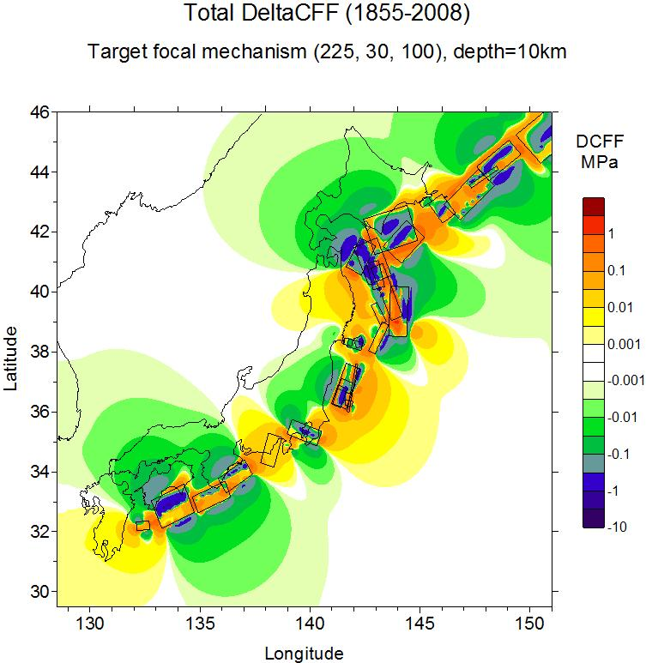
Figure 1

Focusing the attention on the Tokai region, I have computed the Coulomb stress change in a more restricted area and for a target focal mechanism specifically referred to the north-eastern fault segment of the latest Ansei-Tokai earthquake of December 23-24, 1854, characterized by linear dimensions L = 115 km, W = 70 km, and focal mechanism φ = 198°, δ = 34°, λ = 71°. Figure 2 shows the map of ΔCFF for this specific area. In this case the number of grid points was (80x80) = 6,400 with a grid spacing of 5 km, and also in this case the stress change was computed at a constant depth of 10 km.

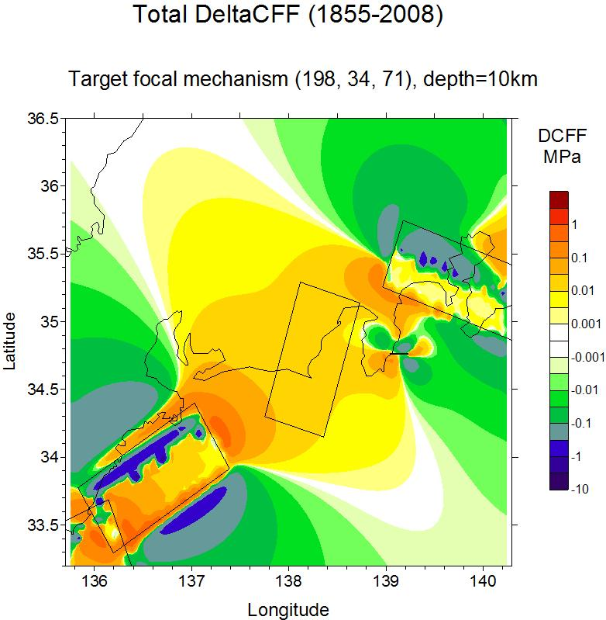

Figure 2

The number of grid points falling in the rectangle of the horizontal projection of the fault rectangle was 267. Among these points, the minimum, average, and maximum ΔCFF values were 0.0089 MPa, 0.0145 MPa, and 0.0364 MPa respectively. Clearly the largest values of ΔCFF were in the points of the fault closer to the sources of the Tonankai 1944 and Kanto 1923 earthquakes, respectively to the south-west and north-east of the Tokai fault. Assuming ΔCFF = 0.0364 MPa as the most conservative solution, we readily obtain a clock change Δt = 1.33 years.
Applying the clock change to modify the recurrence time T_{r} or the elapsed time t, as in equations (4) and (5), the probability of the next characteristic earthquake for the Tokai source, is respectively estimated as 0.1516 (15.16%) and 0.1505 (15.05%).
A more correct approach would require the computation of ΔCFF on the real fault surface, on the rectangle defined by the hypocenter coordinates, linear dimensions of the fault segment, and its focal mechanism solution.
For this purpose, I have developed the necessary algorithm and the computer code here in Tokyo. Also in this case I have used the same dimensions and focal mechanism as in the previous application. Figure 3 shows the results of these computations on a map.
In this case the number of grid points falling in the rectangle of the fault segment was (23x14) = 322 with a spacing of 5 km. Among these points, the minimum, average, and maximum ΔCFF values were 0.0052 MPa, 0.0160 MPa, and 0.0351 MPa respectively. Figure 3 shows even more clearly that the largest values of ΔCFF occur in the points of the fault closer to the sources of the Tonankai 1944 and Kanto 1923 earthquakes. Assuming ΔCFF = 0.0351 MPa as the most conservative solution, we readily obtain a clock change Δt = 1.28 years.
Again, applying the clock change to modify the recurrence time T_{r} or the elapsed time t, as in equations (4) and (5), the probability of the next characteristic earthquake for the Tokai source, is respectively estimated as 0.1515 (15.15%) and 0.1504 (15.04%). The difference in the results obtained for the ΔCFF computed on a horizontal plane at a constant depth of 10km, and on the real fault plane appears negligible. This is probably due to the small dip angle of the fault.

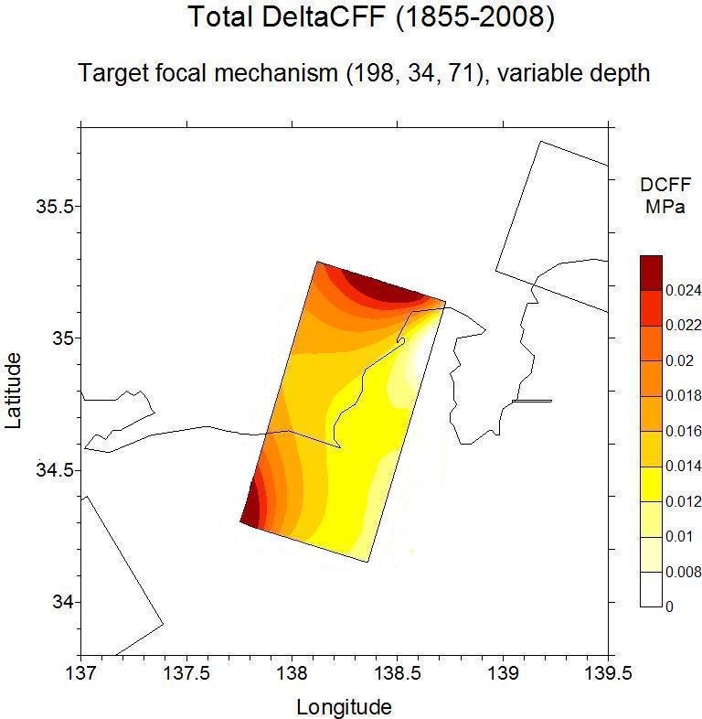

Figure 3

Discussion and conclusions
I have estimated the Coulomb stress change due to all the largest earthquakes of the Japan trench from 1855 to 2008 on the fault segment of the Nankai-Tonankai fault responsible of the “Tokai earthquake”, obtaining a maximum value of 0.035 MPa (i.e. 0.35 bars). This is a relatively modest stress change, I explain it by considering that the rectangles by which fault segments are modeled, are separated from each other by a distance of some tens kms, and their focal mechanism is not the same for all of them.
The effect of this stress change consists only in a slight variation of the hazard for the next characteristic earthquake, estimated according a consolidated statistical method based on the BPT distribution. Namely, the probability of the next characteristic earthquake in 10 years from 1 December 2008 increases from 14.9% to 15.1% approximately. This effect appears very small in comparison with the large uncertainties in the hazard estimate taking into account the errors in the parameters of the BPT statistical model.
As an example, assuming that the aperiodicity parameter “α” can span a range of values from 0.3 to 0.4, the range of variability for the probability (without taking into account the contribution of the Coulomb stress change) would be 13.9% - 17.5%.
Similarly, assuming that the recurrence time T_{r} can span a range of values from 150 to 165 years, the range of variability for the probability would be 13.7% - 16.3%.
The overall range of variability, considering the minimum and maximum result of the combinations of changes in α and T_{r} would be 12.9% - 19.6%.
I conclude saying that the estimated effect of earthquake interaction in the studied case is small if compared with the uncertainties affecting the statistical model used for the basic time-dependent hazard assessment.

References

Console, R., and Catalli, F. 2007, A rate-state model for aftershocks triggered by dislocation on a rectangular fault: a review and new insights, Annals of Geophysics, 49, 6, 1259-1273.

King, G. C. P., Stein, R. S. and Lin, J., 1994, Static stress changes and the triggering of earthquakes, Bull. Seismol. Soc. Am., 84, 935-953.

Matthews, M.V., Ellsworth, W.L. and Reasenberg, P.A., 2002, A Brownian model for recurrent earthquakes, Bull. Seism. Soc. Am., 92, 2233-2250.

Parsons, T., 2005, Significance of stress transfer in time-dependent earthquake probability calculations, J. Geophys. Res., 110, B05S02, doi:10.1029/2004JB003190.

Report of the Coordinating Committee for Earthquake Prediction, 2001.

Sato, R., K. Abe, Y. Okada, K. Shimazaki, and H. Suzuki, 1989. Handbook of earthquake fault parameters in Japan (in Japanese),. Kashima, Tokyo, p. 390.

Stein, R., Barka, A. and Dieterich, J., 1997, Progressive failure on the North Anatolian fault since 1939 by earthquake stress triggering, Geophys. J. Int., 128, 594-604.

Zöller, G., and Hainzl, S., 2007, Recurrence time distributions of large earthquakes in a stochastic model for coupled fault systems: the role of fault interaction, Bull. Seism. Soc. Am., 97, 5, 1679-1687.

