Earthquake Research Institute International Programs Report: MARTHA KANE SAVAGE
Period of Stay at ERI: 1 April-30 June 2008
Host Researcher: Assoc. Prof. T. Ohminato

The collaboration has been very fruitful, and has led to talks at four universities and research centres in Japan, and an abstract submitted to two conferences in Japan, one in New Zealand and one in the U.S. Here is the abstract:
On Mt. Asama Volcano, we tested a new technique to monitor stress changes on volcanoes through the method of shear wave splitting. One goal in understanding the physics of volcanoes is to relate the state of stress to measurable properties. GPS determines strain changes, which are related to changes in stress. But as GPS is measured on the surface, it is not very sensitive to deeper regions and complementary techniques can be helpful. Seismic anisotropy in the upper crust is usually caused by aligned cracks, which open and close in response to changing stress conditions. Anisotropy causes two perpendicular components of shear waves to travel with different speeds; the first arriving wave has a polarization (φ) parallel to the fast orientation of the anisotropic material and the delay time (dt) between the two waves depends upon the integrated effect of anisotropy along the travel path. Thus, φ yields the average crack orientation and dt is proportional to the crack density.

The eruption of Mt. Asama in 2004 was accompanied by a dyke intrusion, which has a simple stress field response and so it is an ideal place to test the shear wave splitting technique. We measured shear-waves splitting on all three-component seismic stations operating on and near Mt. Asama between September 2002 and May 2008. We use two sets of data; local “tectonic” or “a-type” earthquakes from beneath the volcano, which are mostly within the upper 10 km of the crust, and deep earthquakes that originate in the subducting plates and travel through the mantle as well as the crust. Between 2005 and 2008, both sets of data show average fast orientations parallel to the dyke for paths that have passed through the volcanic region, but not close to the dyke. Paths that have traveled through the region close to the dyke (within about one dyke-length, 4 km, away) have fast orientations nearly perpendicular to the dyke. We suggest that the dyke has originated in a regional stress field with maximum principal stress parallel to the dyke, but that in the region close to the dyke, overpressure has caused the principal stress direction to reverse its direction in a local region. Furthermore, splitting along paths that traveled through the mantle appear to be overprinted in orientation by the local stress field, although the delay times of 0.4 to 0.8 s have contributions from both the mantle and crust.

On the longest-operating station, AVO, average delay times measured on deep earthquakes closely parallel the GPS baseline changes between two stations on opposite sides of the dyke. Delay times change by about 0.1 s per 10 cm change in baseline length. If we assume that the change in baseline length is caused by closure and opening of coin-shaped cracks, and that the changes in delay time were caused by a region on the same order as the dyke length, then using the simplest (Hudson, 1981) theory, the crack density changes by about 0.044 and the strain change is 2.5x10-6. Using these two numbers, we calculate the ratio of the crack width to radius of 10-6.
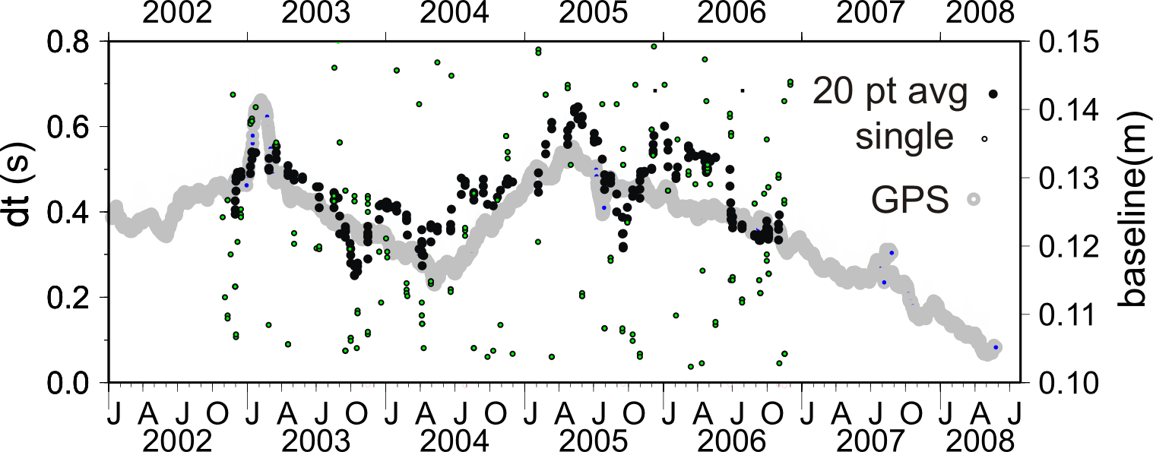
Figure: Single and 20-pt moving average dt measurements overlain on 20-pt moving average of GPS baseline length at Asama Volcano Observatory. Note the individual measurements follow closely the baseline excursion in early 2003.

Talks and Publications relating to this work:

A) At University of Tokyo, mostly about work done before the collaboration:

Thursday May 8th, 17:00-18:30 Title: Seismic Anisotropy in the Mantle under New Zealand
(Authors: Martha Kane Savage, Sonja Greve, Mathieu Duclos, Katrina Marson-Pidgeon (Geophysical Institute, Victoria University of Wellington))
Friday May 9th, 16:00-17:00 1st Conference Room (Building #2, ERI) Speaker: Martha Savage (Victoria University of Wellington, New Zealand) Title: Seismic anisotropy as a possible volcano monitoring tool
Friday, 23 May, 18:30-11:00 Room 843 in the 1st building of the Faculty of Science, Tokyo University Whole Solid Earth Colloquium "Seismic anisotropy and tectonics in New Zealand" (Ms. Savage)
Friday, 6 June 08h30- 11:00 Whole Solid Earth Colloquium, Room 843 in the 1st building of the Faculty of Science
"Crustal Structure of New Zealand determined from Receiver Functions"
By Martha K. Savage, Nick Horspool, Michelle Salmon, Steven Bannister, Sandra Bourguignon, Oliver Boyd
Monday, 23 June: 14:10-14:35 Joint Japanese/French workshop on novel seismological methods for imaging and monitoring of the Earth interiors, Earthquake Research Institute, University of Tokyo, Seminar room (building 1, 3rd floor): Ambient noise imaging of New Zealand : Author Martha Savage, F. Lin, Y. Behr, John Townend, M. Ritzwoller

B) Other talks in Japan that included discussions of the work on Asama: They all had titles similar to this:
Seismic anisotropy as a possible volcano monitoring tool

14 July 10:30-12:00 Disaster Prevention Research Institute, University of Kyoto:
Fri. 18 July Kyushu University, Fukuoka
Tues. 22 July Aso Volcanological Laboratory, Kyoto University, Beppu,
Thurs. 24 July Institute of Seismology and Volcanology, Faculty of Sciences, Kyushu University, Shimabara

Abstract submitted to Japan Seismological Society and Japan Volcanology Society, and American Geophysical Union and New Zealand Geosciences Conference, all to be held in November and December of 2008

Titles and authorship are similar to this:

Changes in stress accompanying the 2004 eruption of Mt. Asama, Japan as measured by seismic anisotropy and GPS: Authors Martha Savage (Victoria University of Wellington, New Zealand), Takao Ohminato, Yosuke Aoki, Hirosi Tsuji (Earthquake Research Institute, University of Tokyo)

