第３章：GPSを用いた地殻変動調査
3.2

A fault model of an aftershock (M5.9) on November 8 and postseismic deformation of the 2004 Niigata Chuetsu earthquake (M6.8) by a dense GPS observation

Hiroaki Takahashi¹, Takeshi Matsushima², Teruyuki Kato³, Akira Takeuchi⁴, Teruhiro Yamaguchi¹, Yuhki Kohno², Takeshi Katagi², Jun’ichi Fukuda³, Kazuya Hatamoto⁴, Ryousuke Doke⁴, Yuki Matsu’ura⁴ and Minoru Kasahara¹

¹Institute of Seismology and Volcanology, Graduate School of Science, Hokkaido University, Sapporo, 060-0810, Japan
²Institute of Seismology and Volcanology, Faculty of Sciences, Kyushu University, Shimabara, 855-0843, Japan
³Earthquake Research Institute, University of Tokyo, Tokyo, 113-0032, Japan
⁴Department of Earth Sciences, Toyama University, Toyama, 930-8550, Japan

Abstract
To investigate the postseismic crustal deformation associated with the 2004 Niigata-Chuetsu earthquake (M6.8), we newly started GPS observation to fill the gap of the nationwide GPS network. Our GPS sites were mainly distributed in the focal region in where there was no permanent GPS site, and succeeded to catch the postseismic deformation. Coseismic displacements of several aftershocks were clearly detected because of immediate observation. We could estimate a fault model of an aftershock (M5.9) on November 8 occurred just beneath our GPS network. Moreover, clear postseismic deformation, which could be characterized by logarithmic decay function, was observed. This signal might suggest possible afterslip. Our results indicated that dense GPS observation could give important and interesting data to clarify the properties of shallow inland middle-size earthquakes.
Key word: The 2004 Niigata-chuetsu earthquake, GPS, postseismic deformation, fault model, afterslip

1. Introduction
The Niigata-Chuetsu earthquake (M6.8) occurred at shallow depth (13km) on 26 October 2004 in Mid Niigata prefecture, central Japan. Focal mechanism estimated by Japan Meteorological Agency (JMA) indicated pure reverse faulting with WNW-ESE compression axis (Fig. 1). Before this earthquake occurrence, several researchers pointed out a seismic gap between the 1847 Zenkoji earthquake (M7.4) and the 1964 Niigata earthquake (M7.6) (Ishikawa, 1995, Tsukuda, 1995, Ohtake, 2002). The 2004 earthquake partially filled this gap but not full.
It has been assumed that plate boundary between Amurian and Okhotsk plates land at the southern edge of the 1964 earthquake fault (Seno et al., 1996, Heki and Miyazaki, 1999, Sagiya, 2000). This hypothesis is consistent with geological and geophysical data in this region, e.g. active structure (Nakata and Imaizumi, 2002), active landslides, strain concentration revealed by nationwide GPS observation (Sagiya et al., 2000), and, of course, high seismicity. We believe this earthquake released strain accumulated by above relative plate motion.
The nationwide continuous GPS network (GEONET) operated by Geographical Survey Institute clearly observed coseismic crustal deformation associated with this earthquake, but there was no site in the focal region. Therefore, it was needed to constructed new GPS sites especially in the focal region to investigate the postseismic crustal deformation properties in detail. In this report, we introduce preliminary results of GPS observation and discuss several characteristics of postseismic crustal deformation.

- GPS observation and Data analysis
The new GPS sites were established immediately after the occurrence of mainshock by Hokkaido University, Kyushu University, University of Tokyo and Toyama University. We first started the observation in October 24, the next day of mainshock, at TODO site. Fig. 1 shows the final distribution of our new GPS sites with GEONET sites. The GEONET sites were located only outside of the aftershock area. In other words, average inter-site distance of GEONET (15-30km) is insufficient for M<7 inland earthquakes because of equivalent or smaller fault size. Therefore, our new sites distributed inner the aftershock region would play very important role for investigation of postseismic deformations. New GPS sites were fixed on the roof top of reinforced-concrete structures using buried stainless bolts, pillars, tripods and/or antenna attachments. We used dual frequency GPS receivers recording carrier phase at every 30 seconds.
In this report, we tried to analyze the data covering about one and half months after the mainshock occurrence. There was no snow covering on GPS antenna during this period. Our GPS data were processed with GEONET data using the Bernese GPS Software Version 4.2 (Hugentobler et al., 2001) with International GPS Service for Geodynamics (IGS) precise ephemeris and International Earth Rotation Service parameters. The station coordinates and tropospheric parameters were estimated daily and every 3 hours, respectively. Two sites of GEONET, that is 950267 (Nagano City) and 950247 (Myoko-Kogen Town, Southwestern Niigata Prefecture) to be sufficient far from the focal region, were selected as reference sites. We confirmed high stability of both sites from seven year’s daily site coordinates since 1996 published by GSI ftp site (ftp://terras.gsi.go.jp). The initial coordinates of reference sites were collocated with the TSKB IGS station in the International Terrestrial Reference Frame 2000 (Altamimi et al., 2002).

3. Result and Discussion
A fault model of an aftershock (M5.9) of November 8, 2004
Fig. 2 shows daily site coordinate series at selected four sites. Clear offsets were recognized on October 27 and November 8 at TODO and NSDN. These steps were induced by aftershocks of a M6.1 and a M5.9, respectively (Fig. 1).
Particularly, many GPS sites recorded coseismic displacements of an aftershock on November 8 because this event occurred at the region in where our GPS sites densely distributed. The maximum coseismic signal of 4.9cm in horizontal and 7.9cm in vertical were observed at TODO and NSDN, respectively. These coseismic data allowed us to estimate a fault model (Fig. 3). Theoretical crustal deformation was calculated using horizontal and vertical components data with same weighting by using a simple, rectangular fault model in an elastic half space (Okada, 1985). We looked for a best fitting fault parameters by grid search procedure. Our estimated fault model explained observed displacements well (Table 1; Fig. 3). These fault parameters were consistent with a focal mechanism determined by JMA using initial P polarizations (Fig. 1). It is noteworthy that relocated precise hypocenter of this earthquake by Shibutani et al. (2005) located up-dip edge of this fault model (Fig. 3). The depth of this was 2.8km, which is approximately consistent with that of geodetic modeling (1km). These suggest rupture ran from shallower part to deeper. Moment magnitude (Mw) of this earthquake from geodetic modeling was 5.7. We here came to conclusion that this earthquake was occurred by a western dipping reverse faulting.

Postseismic signals
Small but detectable postseismic deformation was observed at YKS0, KZWS, HSGS, 950242, 020962, 950240 and 950568 in horizontal component. Maximum postseimic signal of 3.2cm in horizontal component was observed at YKS0. But it was difficult to distinguish postseismic signal at sites in where coseismic displacements of aftershocks were observed, for example, NSDN, TODO, HZKN. However, possible postseimic components of these sites were smaller than a centimeter. Sites with relative large amplitude, that are YKS0 and KZWS, were situated near the mainshock epicenter in where an asperity was estimated (Yamanaka, 2004, Yagi, 2004). Postseismic displacement at 950240, that was 2.1cm, corresponds to the 25% of coseismic one (Fig. 4). Though coseismic displacement at this site was to the westward, postseismic had eastward direction (Fig. 4). This fact may reflect complex faulting in maihshock and aftershock sequence as indicated by seismological data (Shibutani et al., 2005).
The postseismic deformation rate seems to change with time. We tried to estimate the time-dependent relaxation function. To extract the characteristics of this deformation, we examined a logarithmic decaying model, which is commonly used to model afterslip (e.g. Scholz, 1990). The logarithmic decay model is expressed as
R(A,τ)=Aln(1+t/τ)
where t is the time elapsed after the mainshock, A is the amplitude of the function, and τ is the time constant. Unknown parameters, A and τ were estimated from the length of the daily horizontal displacement projected onto the direction along which the horizontal signals are the largest for each GPS site. Estimated τ at YKS0, in where maximum postseismic signal was observed, was 1.6 days. We suppose this rapid decay is one of typical characteristics of afterslip of large earthquake (Scholz, 1990). If the postseismic crustal deformation is the manifestation of the same afterslip at depth, the time constant should be same for all sites. Therefore, we estimated amplitudes of this decay function by fixing the time constant as YKS0’s value. Sites with little coseismic deformation of October 27 and November 8 aftershocks were selected for analysis, and the results were shown in Fig. 6. As mentioned above, it is noteworthy again that relative large postseimic amplitudes were distributed near the mainshock asperity (Yamanaka, 2004; Yagi, 2004). This might imply possible relative large afterslip on a mainshock asperity.

- Conclusion
We successfully established new GPS sites in the focal region of the 2004 Niigata-Chuetsu earthquake (M6.8) immediately after the mainshock. Analysis of data obtained for a period of one and half months after the mainshock clearly recorded the coseismic displacements by a M5.9 aftershock and horizontal postseismic deformation. A M5.9 fault model estimated by our data well explained the observed displacements, and consistent with focal mechanism from seismological data. Coordinate time series were modeled with a logarithmic function, which agree with the characteristics of afterslip of a large earthquakes. Postseismic signals were relatively larger at sites near the mainshock asperity, which implied possible afterslip on a mainshock asperity.

Acknowledgements We are grateful to the staff of schools, local governments and farmers cooperative who permitted us to install GPS receivers. Makiko Iwakuni at University of Tokyo, Sayaka Uchiumi and Yasuko Shimizu at Tokai University help us to collect observation data. We obtained GPS RINEX data from Geographical Survey Institute of Japan, which is appreciated. Focal mechanism data in Fig. 1 were from JMA’s home page (http://www.jma.go.jp). Hypocenter data in Fig. 1 were quickly determined by JMA in cooperation with the Ministry of Education, Culture, Sports, Science and Technology (MEXT) to analyze seismic wave data provided by cooperative organizations, that is Hokkaido Univ., Hirosaki Univ., Tohoku Univ., University of Tokyo, Nagoya Univ., Kyoto Univ., Kochi Univ., Kyushu Univ., Kagoshima Univ., National Research Institute for Earth Science and Disaster Prevention, National Institute of Advanced Industrial Science and Technology, the Tokyo Metropolitan Government, Shizuoka Prefecture, Hot Springs Research Institute of Kanagawa Prefecture, Yokohama City, Geographical Survey Institute and Japan Marine Science and Technology Center. This research is supported by the New Program for Earthquake Prediction Research and Observation, and Grand-in-Aid for Scientific Research (representative; N. Hirata) of MEXT of Japan Government. Fig.s were partially drawn using GMT software (Wessel and Smith, 1995).

References
Altamimi, Z., P. Sillard, and C. Boucher, ITRF2000: A new release of the International Terrestrial Reference Frame for earth science applications, J. Geophys. Res., 107, 2214, doi:10.1029/2001JB000561, 2002.
Heki, K., and S. Miyazakim, Plate convergence and long-term crustal deformation in central Japan, Geophys. Res. Lett, 28, 2313-2316, 2001.
Ishikawa, Y., Northern Niigata Earthquake and seismic gap, Earth Monthly, 17,784-788, 1995.
Hugentobler, U., S. Schaer, and P. Fridez, Bernese GPS Software Version 4.2, University of Bern, 515pp, 2001.
Nakata, T., and T. Imaizumi, ed., Digital active fault map of Japan, University of Tokyo Press, 2002.
Ohtake, M., Earthquake occurrence potential in eastern margin of the Japan Sea, in Active faults and seismi-tectonics of the eastern margin of the Japan Sea, ed. by Ohtake, M., A. Taira, and Y. Ohta, University of Tokyo Press, 2002.
Okada, Y., Surface deformation due to shear and tensile faults in a half space, Bull. Seis. Soc. Am., 75, 1135-1154, 1985.
Sagiya, T., S. Miyazaki, and T. Tada, Continuous GPS Array and Present-day Crustal Deformation of Japan, PAGEOPH, 157, 2303-2322, 2000.
Scholz, The mechanics of Earthquakes and Faulting, Cambridge University Press, 1990.
Seno, T., T. Sakurai, and S. Stein, Can the Okhotsk plate be discriminated from the North American plate?, J. Geophys. Res.,101, 11305-11315, 1996.
Shibutani et al., in this issue, 2005.
Tsukuda, T., Possibility of large earthquake occurrence in Niigata plain, Earth Monthly, 17, 789-796, 1995.
Yagi, Y., http:// http://iisee.kenken.go.jp/staff/yagi/eq/20041023/, 2004.
Yamanaka, Y., EIC seismological note, no.154, http://www.eri.u-tokyo.ac.jp/sanchu/Seismo_Note/, 2004.
Wessel, P., and W. H. F. Smith, New Version of the Generic Mapping Tools Released, EOS Trans. AGU, 76, 329, 1995.

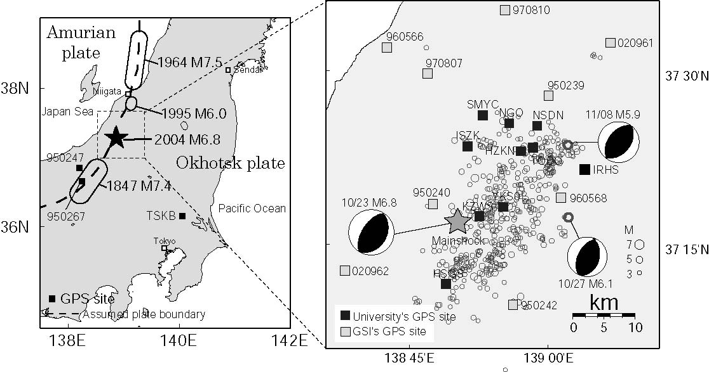
Fig. 1. Map showing the GPS sites. Focal regions of neighboring shallow large earthquakes along the plate boundary between the Amurian and Okhotsk plates (left) and M≧3 Aftershocks during a period from October 23 to December 15, 2004 (right), were also indicated. Mechanism solutions and epicenter distribution data were from Japan Meteorological Agency.
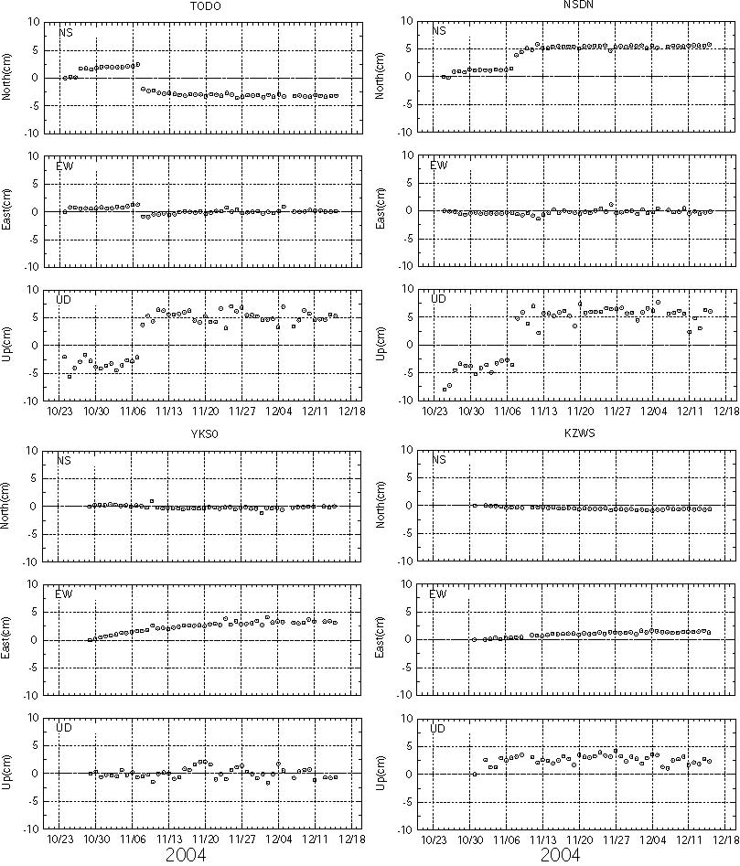
Fig. 2. Time series of coordinates at selected sites for the one and half months after the mainshock.
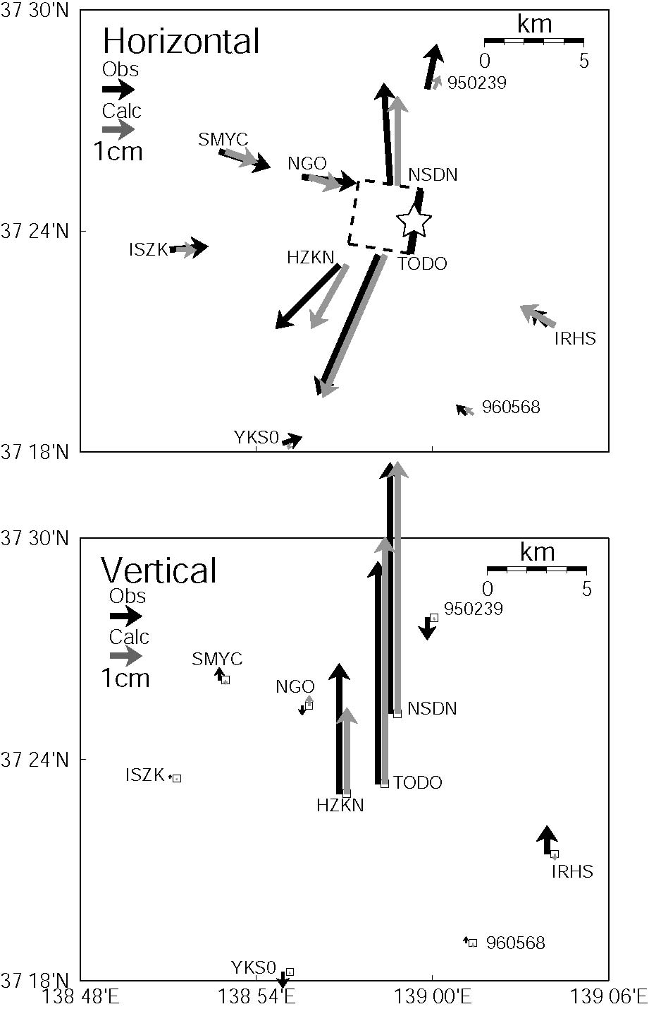
Fig. 3. Observed and calculated coseismic displacement field of an aftershock of November 8 (M5.9). Estimated fault plane was also indicated. A star showed relocated epicenter of this earthquake by Shibutani et al. (2005).
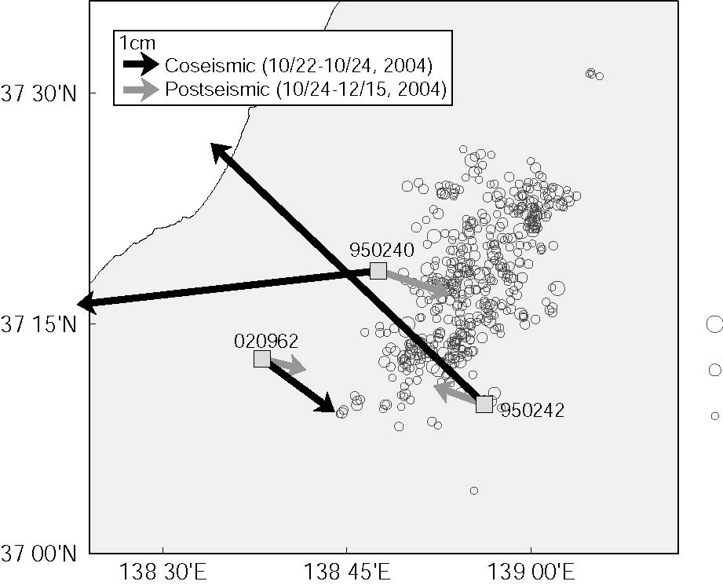
Fig. 4. Comparison of coseismic and postseismic horizontal displacement vectors at GPS sites. Postseismic vector at 950240 indicates opposite direction of coseismic one.
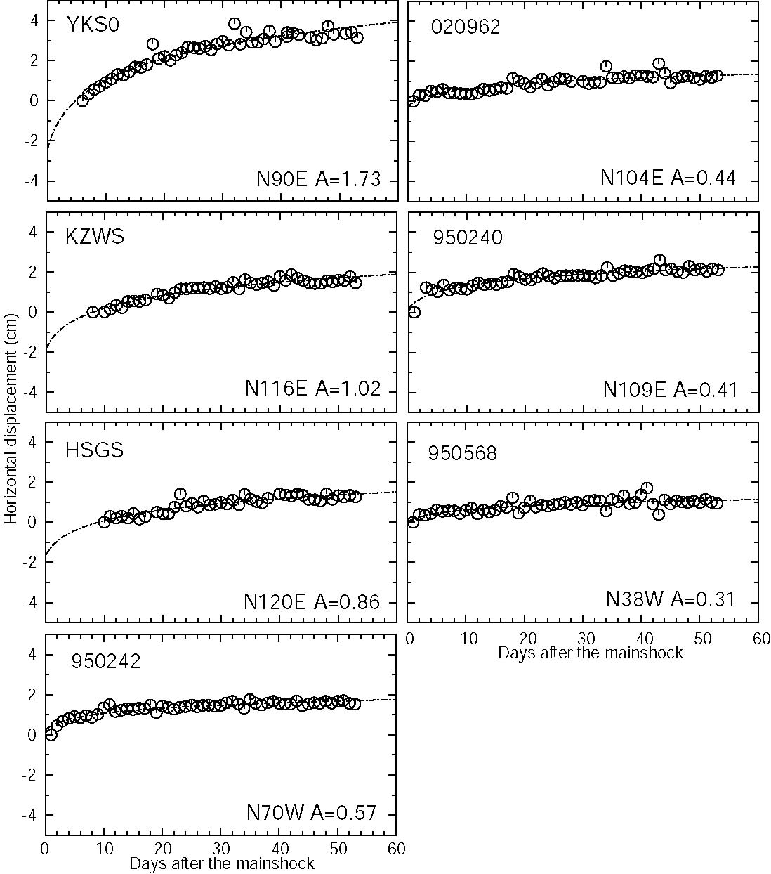
Fig. 5. Time series of length of the daily horizontal displacement projected onto the direction along which the horizontal signals are the largest. Direction in degree and amplitude in cm (A) were also shown.
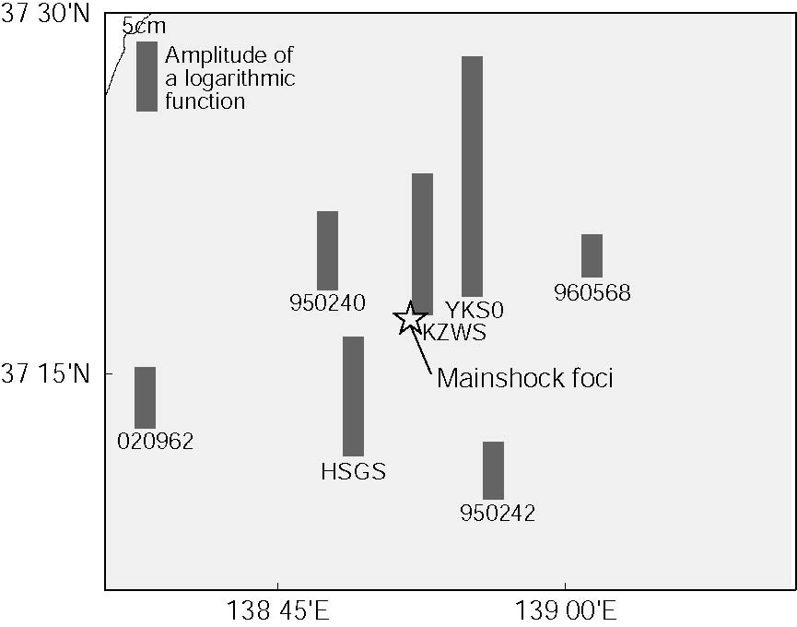

Fig. 6. Amplitude distribution of a logarithmic decay functions. Only sites with little coseismic deformation of October 27 and November 8 earthquakes were shown.

