５章 強震動観測による地殻及び基盤構造の調査

5.2

Estimation of local site effects in the Ojiya city
using aftershock records of the 2004 Chuetsu earthquake and microtremors

Hiroaki YAMANAKA, Kentaro MOTOKI
(Interdisciplinary Graduate School of Science and Engineering, Tokyo Institute of Technology)
Shun’ichi FUKUMOTO, Toshiyuki TAKAHASHI ,
(Tokyo Soil Research)
Nobuyuki YAMADA, Kimiyuki ASANO
(Disaster Prevention Research Institute, Kyoto University)

Abstract
Aftershock observations of the 2004 Chuetsu earthquake was conducted in the central part of Ojiya city, the Niigata prefecture, central Japan, to investigate local site effects. In the vicinity of the K-NET and JMA stations in the area, we installed 8 accelerographs. The stations of the aftershock observation are situated with different geological conditions including one installed in mountainous area on Tertiary layers to serve as a reference site. We examined ground motion characteristics of the records for Mj 6.1 aftershock focusing on local site effects. The amplification at period less than 1 s is the largest in the vicinity of the K-NET station. The amplification at periods longer than 2 s is larger in the west part of the city than those in the east. We estimated S-wave velocity structure in the sediments above the basement with an S-wave velocity of 3.4 km/s from the inversion of phase velocities measured by the array observations of vertical microtremors. We discuss amplification factors using the S-wave velocity profile and found that shallow soils over the layer with an S-wave velocity of 0.49 km/s are responsible for the amplification at periods shorter than 0.4 seconds. Deeper sedimentary layers are needed to explain amplification at periods of 1 second.

1. Introduction
The 2004 Chuetsu earthquake occurred on the 23rd October, 2004 in the Niigata prefecture in central Japan. This is a shallow moderate earthquake (Mj 6.8) with many M6 aftershocks. Damages of building and wooden houses and landslides were observed in the vicinity of the fault. It was reported by Japan Meteorological Agency (JMA) that the seismic intensities during the main shock are 6-upper and 7 in the Ojiya city and Kawaguchi-machi, respectively. Strong ground motions of the main shock were recorded in the Ojiya city by the K-NET and JMA. It was found from a quick analysis of the strong motion records that peak ground acceleration (PGA) and peak ground velocity (PGV) are approximately 1.4G and 1.3m/s at the K-NET site in the Ojiya city (Aoi et al., 2004). Although the ground motion is as large as those observed in the heavily damaged area of the 1995 Hyogoken-Nanbu earthquake, wooden houses and buildings were not always severely collapsed in the vicinity of the K-NET site. To understand the damage distribution, variation of the ground motion characteristics must be clarified. In particular, site amplification of the sedimentary layers should be properly estimated.
In this study, we analyzed the aftershock records to understand site amplification factors in Ojiya city. We mainly used the records due to the M6.1 aftershock on the 25th October. We also conducted a microtremor array observation to explore S-wave velocity structure in the city.

2. Observation of aftershocks
The observation of the aftershocks was conducted from the 26th to the 30th, October at 8 temporary stations in Ojiya city (Fig.1). The locations of the stations are also tabulated in Table 1. The station OJY01 is located in the eastern hilly area which covered with Tertiary sandstone or gravel（Yanagisawa et al，1986）. We regarded this station as the reference site in the following analysis. The other stations are situated on Quaternary layers from the west to the east. It is noted that surface geology for these sites on the Quaternary layers is classified in terrace deposits with gravel or sand (Yanagisawa et al, 1986). Our temporary stations are located around the stations of the K-NET and JMA, because one of our objects is to understand the differences in strong ground motions observed during the main shock (e.g., Aoi et al, 2004).
A three-component accelerometer and a 14bit-digital recorder were temporarily installed on the surface at each station. The instrument is continuously operated in several days with a battery. Recording started with a triggering signal generated by ground acceleration and continued about 2 minutes. The observation was started in the evening in the 26th, October until 10:00 on the 29th, October, 2004.

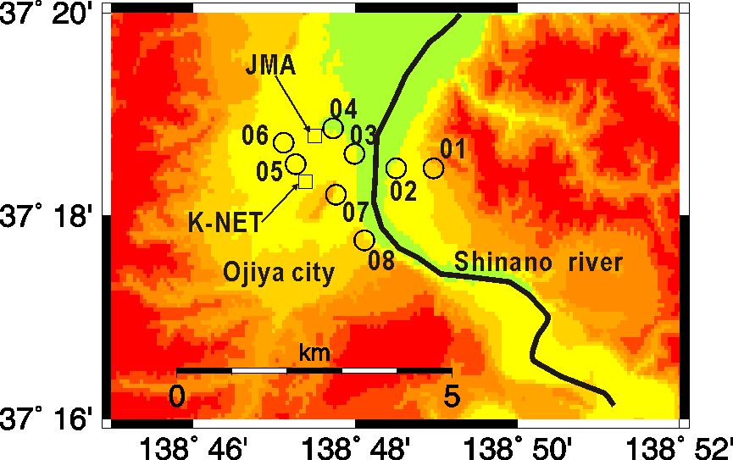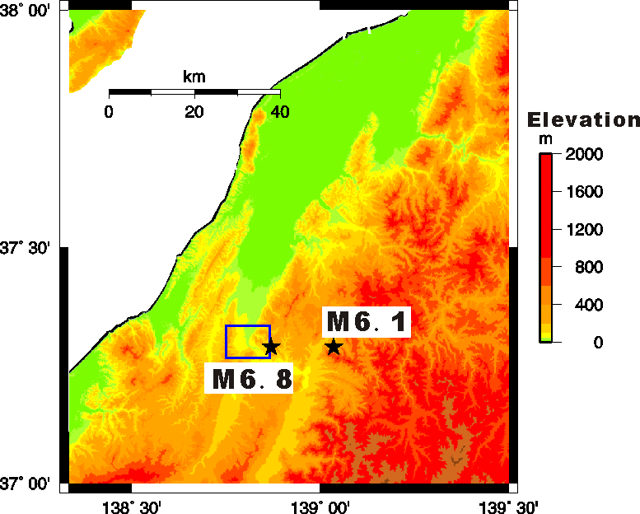

Fig.1 Locations for stations in Ojiya city (left). Stars in right figure show locations of main shock and aftershock used in this study. The square area in the right figure indicates area for map in the left.

Table 1 Locations of aftershock observation stations in Ojiya city
Site code | Location | Latitude | Longitude
OJY01 | Hiu | 37.30779 | 138.81609
OJY02 | Touei | 37.30782 | 138.80856
OJY03 | Motomati | 37.31017 | 138.79983
OJY04 | Jyounai, Ojiya city hall | 37.31433 | 138.79550
OJY05 | Tsuchikawa | 37.30851 | 138.78773
OJY06 | Sakuramachi | 37.31199 | 138.78532
OJY07 | Funaoka | 37.30347 | 138.79603
OJY08 | Yamamoto | 37.29599 | 138.80193

3. Analysis of aftershock records
Estimation of Site amplification
The largest aftershock (Mj6.1) was observed in our aftershock observation stations at 10:40 (UT+9h) on the 27th October, 2004. This is the aftershock whose fault plane is conjugate to that of the main shock (Kato et al., 2005). It is reported that the seismic intensity is 5 upper in the Ojiya city and some houses that had damaged during the main shock were collapsed. Ground velocity integrated from the acceleration records are displayed in Fig.2 together with the records observed by the K-NET and JMA. The velocity in the figure was filtered in a period range from 0.1 to 10 s. Unfortunately, no records are available at the station OJY07 during this event because of instrument troubles. It can be seen that high frequency motion is dominant at the stations of K-NET, JMA and OJY05. The high-frequency motion is not dominant at OJY06, although the station is only 0.5km apart from the OJY05. Furthermore, we can see a large S-wave pulse in the east-west component at all the sites. Figure 3 shows the particle motion of the ground velocities filtered in a period range from 1 to 5 s. All the motions are dominant in the direction normal to the fault plane. This feature can be interpreted as source effects of the fault rupture. Since all the stations are located in similar azimuth from the epicenter in Fig.1, the source effects is considered to be the same at the stations. In the followings, we assumed the variation of the ground motion is caused by local site effects.

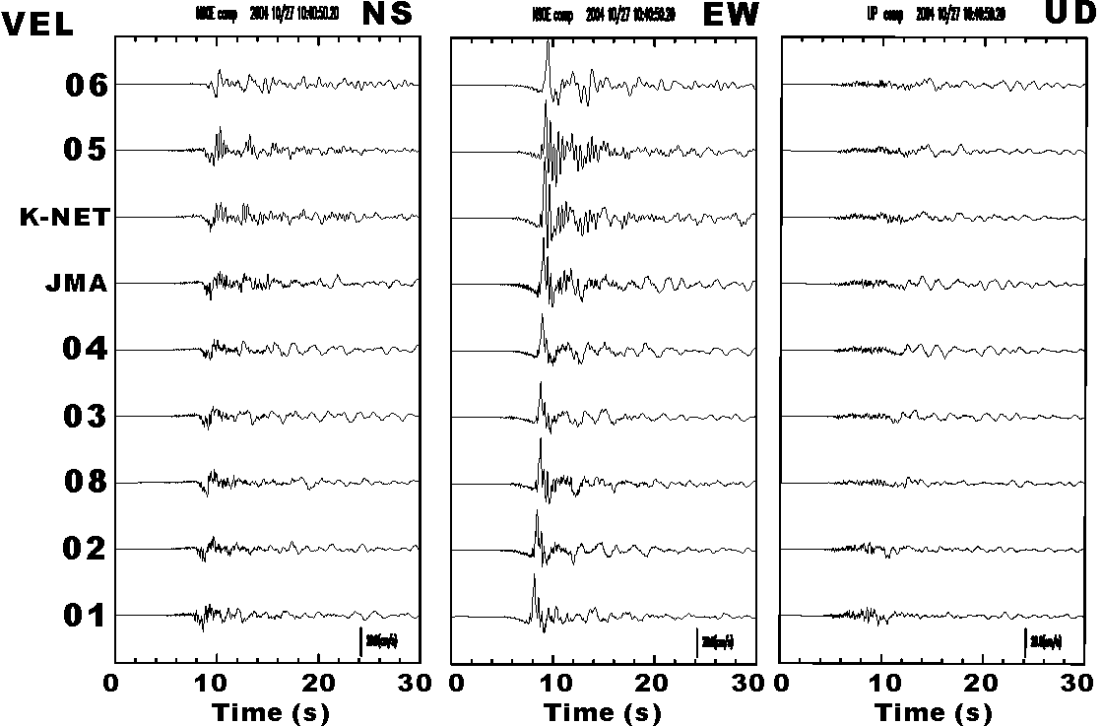
Fig.2 Ground velocities of aftershock at 10:40 on 27th October with an Mj of 6.1. East-west (left), north-south (middle) and vertical (right) components are displayed. Each trace was calculated from integration of acceleration records with a band-pass filtering at periods from 0.1 to 10 seconds.

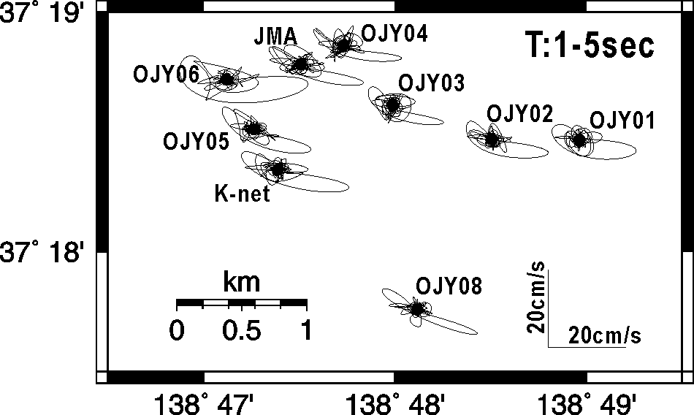
Fig.3 Particle motion of horizontal ground velocity in a period range from 2 to 5 s for the aftershock at 10:40 (UT+9h) on 27th October, 2004.

Seismic intensities for the aftershock are calculated as shown in Fig.4a. The seismic intensity is the maximum at K-NET station and OJY05, while the smallest was about 4.8 at OJY03 and 04. The similar feature of the variation of the ground motion characteristics can be seen in the distribution of the peak ground velocity (PGV) (Fig.4b). The PGV at K-NET station is 1.8 times as large as that at OJY07. The peak ground acceleration (PGA) in Fig.4c shows a slightly different spatial variation: the largest PGAs are identified not only at the K-NET site and OJY05 but also at OJY02. These different features in the spatial variations of the seismic intensity, PGA, and PGV can be explained by different frequency-dependent site amplifications. We, therefore, calculated 2D pseudo velocity response spectra with a damping of 5 % as shown in Fig.5. The large peaks can be seen at periods of 0.4 to 0.5 s in the spectra at the K-NET and OJY05 stations where the seismic intensities are the largest. The spectrum at JMA station has a shorter predominant period than those at K-NET and OJY05 stations. The similar difference of the predominant periods can be found in the strong motion records at K-NET and JMA stations (Aoi et al, 2004), though the predominant periods are different from those for the main shock because of the effects of non-linear amplification of superficial soils. The spectra at the stations in the east of OJY04 are relatively flat as compared with that for the K-NET station. It is noted that the spectral amplitudes at periods of 2 to 3 seconds show a spatial variation where the amplitudes in the western part of the city (OJY05, 06, K-NET and JMA stations) are larger than those in the east. In order to discuss these spatial variations of the local site effects, we calculated Fourier spectral ratio of the horizontal motions at each station to that for OJY01. Figure 6 shows the distribution of the frequency-dependent spectral ratio with their peak periods. The ratio in the figure indicates the maximum value in each period range. The amplification in a short period range from 0.25 to 1 s is large at the OJY05 and K-NET stations similar to that of the PGV. They can also be identified in the variation of the peak periods in Fig. 6c. On the other hand, the amplifications at these sites are not large in shorter periods of 0.1 to 0.25 s. As pointed out by Aoi et al. (2004), the very shallow soils are responsible for the amplification in the short period range. This amplification in a period range from 2 to 5 s shown in Fig.6b is large at the sites located in the west of the Shinano River, indicating different effects of deep subsurface structure. Thus the local site amplification in Ojiya city is different in a wide period range and such effects should be included in the estimation of strong ground motion during the main shock.

a)
c)
b)
Fig.4 Distributions of a) seismic intensity, b) PGV and c) PGA of horizontal motions for the Mj6.1 aftershock on 27th October, 2004.
Fig.5 Response spectra with a damping of 5% for the Mj6.1 aftershock on 27th October, 2004.

a)
b)
c)
Fig.6 Spectral ratios at periods of a) 0.1 to 0.25 s and 0.25 to 1.0s, b) 2 to 5 s together with c) peak period.

Array analysis of later phases
A further investigation on the ground motion characteristics at K-NET station was conducted using a semblance analysis for the aftershock records observed at 4 stations (OJY05, 06, K-NET and JMA stations). Figure 7 shows the results of the array analysis of the east-west component of ground velocity. The upper trace is the filtered velocity at the K-NET station, and lower two figures indicate slowness and propagation direction estimated in the semblance analysis. The propagation velocity is about 2 km/s and the propagation direction is the same as the epicentral azimuth for the initial S-wave part. This result clearly indicates that the initial S-wave part with duration of 10 s can be explained by a 1D propagation of S-wave. However, the later phases at 30 s have a low velocity of about 0.8 km/s. The propagation direction for the later phases is out of the epicentral direction suggesting complex 3D effects of the sedimentary layers in the area.
a)
b)
c)
d)
Fig.7 Results of semblance analysis for the east-west oriented velocity for the Mj6.1 aftershock on 27th October, 2004 in a period range from 2 to 5 s. Trace in the top is a) filter velocity, and lower three figures show b) semblance, c) slowness and d) back azimuth estimated in the analysis.

4. Estimation of S-wave profile using microtremors
A microtremor array exploration was conducted in the area to estimate an S-wave profile down to the basement. We deployed temporary arrays of vertical seismometers to observe vertical microtremors simultaneously. The configurations of the arrays are depicted in Fig.8a. The large and middle arrays consist of stand-alone instruments that are synchronized with a GPS time signal, while three small arrays with four instruments are deployed in a circle with radii of 2, 8 and 25 meters. It is noted that the small arrays are located between the stations OJY05 and 06.
We applied frequency-wavenumber spectral analysis (Horike, 1985) to the vertical microtremors obtained in the large and middle arrays. For the data from the small arrays, spatial-autocorrelation method (Okada, 2003) was used to estimate phase velocity. Figure 8b shows the phase velocity derived from the analysis. The phase velocity exhibits dispersive features in a wide period range from 0.1 to 5 s. Therefore, we interpret it as phase velocity of fundamental Rayleigh wave.
We, next, invert the phase velocity using genetic algorithms by Yamanaka and Ishida (1996). In the inversion, S-wave velocity and thickness for each layer are determined so as to fit the observed phase velocity with the calculated Rayleigh wave phase velocity. P-wave velocity is calculated using an empirical relation with S-wave velocity (Kitsunezaki et al, 1990) and density is given in advance. We also assumed the P- and S-wave velocities of the half-space. The S-wave velocity inverted is tabulated in Table 2. The theoretical phase velocity explains well the observed one as compared in Fig. 8b. The depth to the basement with an S-wave velocity of 3.4 km/s is more than 5 km. The depth to the one of the Tertiary sedimentary layers is reported to be more than 5km around the Ojiya city (Yanagisawa et al, 1986), which agrees with our results. In Fig 8b, phase velocity for the fundamental Love wave is also shown. The Love wave phase velocity at periods around 2 s is about 0.8 km/s for the inverted model. This phase velocity of Love wave is in good agreement with that estimated in the semblance analysis of the long-period motion.
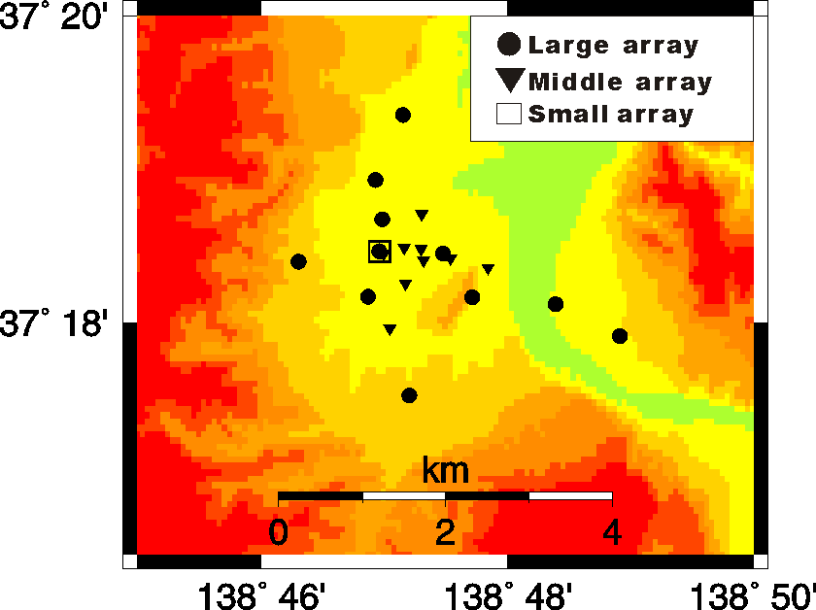
a)
b)
Fig. 8 Results of microtremor array exploration. a) Locations of stations in temporary arrays. b) Comparison of phase velocity obtained from microtremor array exploration (solid circle) with calculated one (solid line) for fundamental Rayleigh wave in the inverted S-wave profile shown in Table 2. Phase velocity for fundamental Love wave is also shown by a broken line.

Table 2 Subsurface structure model estimated from microtremor array exploration in Ojiya city
Vs (km/s) | Vp (km/s) | Thickness (km) | ρ (kg/m³)
0.15 | 1.46 | 0.01 | 1700
0.34 | 1.67 | 0.04 | 1800
0.49 | 1.83 | 0.05 | 1800
0.65 | 2.01 | 0.21 | 2000
1.22 | 2.64 | 0.64 | 200
1.53 | 2.99 | 1.60 | 2100
2.35 | 3.90 | 3.00 | 2500
3.40 | 5.89 | － | 2700
5. Discussion
We obtained the 8-layer model for the S-wave profile including the basement with an S-wave velocity of 3.4 km/s (Table 2). We then examine the effects of the S-wave velocity of the bottom layer in estimation of amplification factors. The theoretical amplification factors are calculated by removing the lower layers and assuming that the bottom layer extends to infinity. Figure 9 shows the variation of the theoretical amplifications calculated for the models with different S-wave velocities of the half space. In the calculation, Q-value is assumed to be Vs/15. The thin solid line indicates the amplification of the model with a bottom layer having an S-wave velocity of 3.4 km/s, in which effects of all the sedimentary layers in the model in Table 2 are taken into account. The amplification shown by the thin dotted line is calculated for the model where the 7th layer with an S-wave velocity of 2.35km/s is assumed as the half space. Similarly, the thick solid line stands for the amplification for the model whose bottom layer has an S-wave velocity of 1.22 km/s. The comparisons of the amplifications clearly indicates that the importance of top two low velocity layer in determining the amplification factors at periods shorter than 0.3s, because the peak at 0.25 s can be seen in all the amplification. However, the spectral peak at 0.8s is affected by deeper sediments over the layer with an S-wave velocity of 1.22 km/s. Furthermore, we must consider effects of much deeper layers in estimation of the amplification at periods of longer than 1.0s, because the 5-layers model can not generate the peak at 2.5s
Figure 10 shows the comparison of the response spectra (h=5%) at the K-NET in the Ojiya city for the main shock and the aftershock. Although the spectral peaks are identified at different periods because of non-linear effects of shallow soils (e.g., Aoi et al., 2004), the spectral shapes are very similar to each other. It is clearly indicated from our aftershock observation that the site amplification in the vicinity of the K-NET station is the largest in Ojiya city. Therefore, it is expected that the ground motion at the K-NET station is the most severe in the city during the main shock. The figure also compares the response spectrum observed at Kawaguchi-cho during the main shock together with the spectrum at Takatori during the 1995 Hyogo-ken Nanbu earthquake. The JMA seismic intensities at Kawaguchi-cho and Takatori were both 7 with heavy damage. The two spectra are larger at periods from 1 to 2 seconds than that in the Ojiya city. It is indicated that the spectral amplitudes at this periods significantly affect structural damage (Aoi et al., 2004). This suggests one of probable reasons for the small damage in Ojiya city.
Fig.9 Variation of amplification factors with different S-wave velocities for the bottom layer of S-wave model shown in Table 2.

Fig.10 Response spectra (h=5%) at K-NET Ojiya for the main shock (thick solid line) and the Mj6.1 aftershock (thin line) on 27th October, 2004. Response spectra at Kawaguchi-cho (thick broken line) during the main shock and at Takatori (thick dotted line) during the 1995 Hyogo-ken Nanbu earthquake are also depicted.

6. Conclusions
We conducted aftershock observations of the 2004 Chuetsu earthquake in Ojiya city to investigate local site effects. The accelerometers were temporarily installed at 8 sites in the central part of the city. We discussed the variation of the local site effects using the records from the Mj6.1 aftershocks occurring on the 27th, October 2004. The amplification in a period range less than 1 s is the largest at the K-NET station and the adjacent sites due to the superficial shallow soft soils. However, the amplification at periods longer than 1 s is larger in the western part of the city than those in the eastern side, suggesting the effects of the deep sedimentary layers. The semblance analysis of the aftershock records at the sites near the K-NET station indicated that the long-period later phases in the east-west direction is Love waves propagating in the sedimentary layers. The microtremor array exploration was conducted in the area to know the S-wave profile down to the basement with an S-wave velocity of 3.4 km/s. We discussed the amplification factors using the S-wave velocity profile and found that shallow soils over the layer with an S-wave velocity of 0.49 km/s are responsible for the amplification at periods shorter than 0.4 seconds. Deeper sedimentary layers are needed to reproduce the amplification at periods of 1 second.

Acknowledgements
The comments from E. Fukuyama, M. Horike and anonymous reviewer are very helpful to improve manuscript. We also thank Hitoshi Tanaka, Etsuko Yamada, Nobuhiko Komaba, Kaoru Ohtahara, and Kentaro Kasamatsu for the field observation. This study was supported by the Grant-in-Aid for Special Purposes (16800054), the Special Coordination Funds titled Urgent research on the Mid-Niigata prefecture Earthquake in 2004 of Ministry of Education, Culture, Sports, Science and Technology (MEXT), and 21st Century Center of Excellence (COE) program titled Evolution of Urban Earthquake Engineering of the MEXT. A part of the ground motion data used in this study are provided by the K-NET of National Research Institute for Earth Science and Disaster Prevention and by Japan Meteorological Agency and Japan Railway． Some of the figures in this paper were made using GMT (Wessel and Smith, 1991).

References
Aoi, S., N.Morikawa, R. Honda, H. Sekiguchi, T. Kunugi and H. Fujiwara, Large ground-motion observed during 2004 Niigataken-Chuetsu earthquake, Summary on Reconnaissance Report of the 2004 Niigataken-Chuetsu Earthquake, Japan, Association for Earthq. Eng., 19-26, 2004 (in Japanese).
Hirata, N., H.Sato, S. Sakai, A. Kato, and E. Kurashimo, Fault system of the 2004 Mid-Niigata Prefecture Earthquake and its aftershocks, Landslides, 2005 (submitted)
Horike, M., Inversion of phase velocity of long-period microtremors to the S-wave velocity structure down to the basement in urbanized areas, J. Phys. Earth, 33, 59-96, 1985.
Kato A., Kurashimo E, Hirata N., Iwasaki T., Kanazawa T, Imaging the source region of the 2004 Mid-Niigata prefecture earthquake and the evolution of a seismogenic thrust-related fold, Geophy. Res. Lett., 2005 (submitted).
Kitsunezaki C., N. Goto, Y. Kobayashi, T. Ikawa, M. Horike, T. Saito, T. Kurota, K. Yamane, and K. Okuzumi, Estimation of P- and S- wave velocity in deep soil deposits for evaluating ground vibrations in earthquake: Jour. Japan Soc. Natural Disaster Science, 9, 1-17, 1990 (in Japanese).
Okada, H., 2003, The microtremor survey method: Soc. Exp. Geophy., Tulsa, OK.
Yanagisawa, Y., I. Kobayashi, K. Takeuchi, M. Tateishi, K. Chihara, and H. Kato, Geology of the Ojiya district, Geological Survey of Japan, 1986 (In Japanese).
Wessel, P. and W.H.F. Smith, Free software helps map and display data, EOS, Trans. Amer. Geophys. U., 72, 441, 445-446, 1991
Yamanaka, H. and H. Ishida, Application of genetic algorithms to an inversion of surface-wave dispersion data, Bull. Seism. Soc. Am. Vol.86, 436-444, 1996.

