International Symposium on the Restoration Program from Giant Earthquakes and Tsunamis – Template for preparing abstract –

Teruyuki Kato¹, Kenji Satake², Koshun Yamaoka³, Fumihiko Imamura⁴, Hirokazu Iemura ⁵

¹Institute Name, University Name, Street, Town, City, Province Postal/ZIP Code, Country (e-mail@add.ress)
² Institute Name, University Name, Street, Town, City, Province Postal/ZIP Code, Country
³ Institute Name, University Name, Street, Town, City, Province Postal/ZIP Code, Country
⁴ Institute Name, University Name, Street, Town, City, Province Postal/ZIP Code, Country
⁵ Institute Name, University Name, Street, Town, City, Province Postal/ZIP Code, Country

The symposium is to conclude the three year project of “The Restoration Program from Giant Earthquakes and Tsunamis” that started in April 2005. The primary objective of the project is to propose long-term countermeasures against disasters due to giant earthquakes and tsunamis, such as the 2004 Indian Ocean Earthquake and Tsunami (Reference, 200x).
This document is a template for the abstract that is to be submitted for presentation .

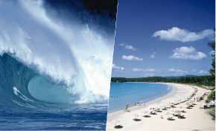
Fig.1 Logo mark adopted for the project (left) and an image of Tsunami at Phuket (right: Kato et al., 2007) for the 2004 Sumatra-Andaman earthquake.

A two page abstract should be submitted. Template for the abstract can be downloaded from the symposium webpage (http://www.eri.u-tokyo.ac.jp/sumatra/index-e.html).
The following information should be clearly stated on the first page.
- Title and optional subtitle of the paper
- Author names
- Affiliations of Authors
- Postal addresses of all authors and an e-mail address of the contact author
The author that presents the paper should be underscored. For the purpose of editing, the usage of a standard word processor such as Microsoft WORD is strongly recommended. The collected abstracts will be edited and distributed at the symposium.

Detailed instructions for abstract format are as follows:
- Paper size: A4 (210mm x 297mm) or U.S letter size (8 1/2"x 11")
- Headings: Title, author(s)' name(s), affiliation(s), and postal address(es) for the authors to be aligned left. E-mail of the contact author should be included.
- Typing area: Single spaced in 154mm x 225mm (or 6" x 8 7/8"), with margins of 28mm (1 1/4") at the left, and 25mm(1") at the top of the paper
- Length: Two pages (In order to align the page format, NOT ONE PAGE BUT TWO PAGES of abstract is strongly recommended)
- Font: “Palatino Linotype” will be used for print. Similar fonts such as “Times New Roman” or “Century” are allowed but will be converted to “Palatino Linotype” in editing.
- Characters: Title(14pt, Bold), Authors(12pt, Bold), Affiliations(12pt), Text(10.5pt)
- One or more figures are allowed to insert in the abstract with proper layouts and captions.
- Language: English

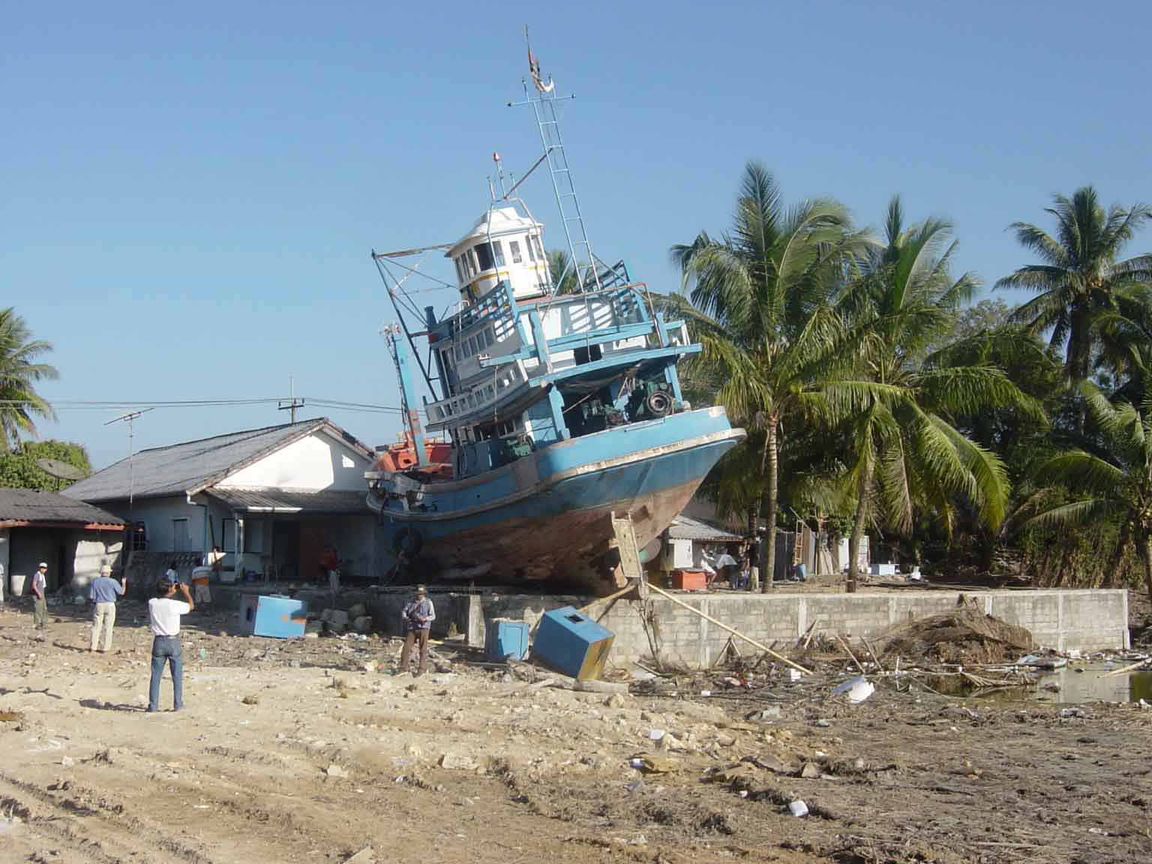
Photo 1 A wrecked ship at Ban Nam Ken, Thailand. By courtesy of K. Satake (2005).

Collected abstracts will be edited for printing the abstract book. Send the abstract to the symposium secretary as an attached electronic document.
Full paper will be collected for the symposium proceedings. More detailed announcements will be notified later.

References
Kato, T, K. Satake, K. Yamaoka, F. Imamura and H. Iemura, International symposium on the restoration program from giant earthquakes and tsunami, Earth Planets Space, 999, 1-2. 2007.

